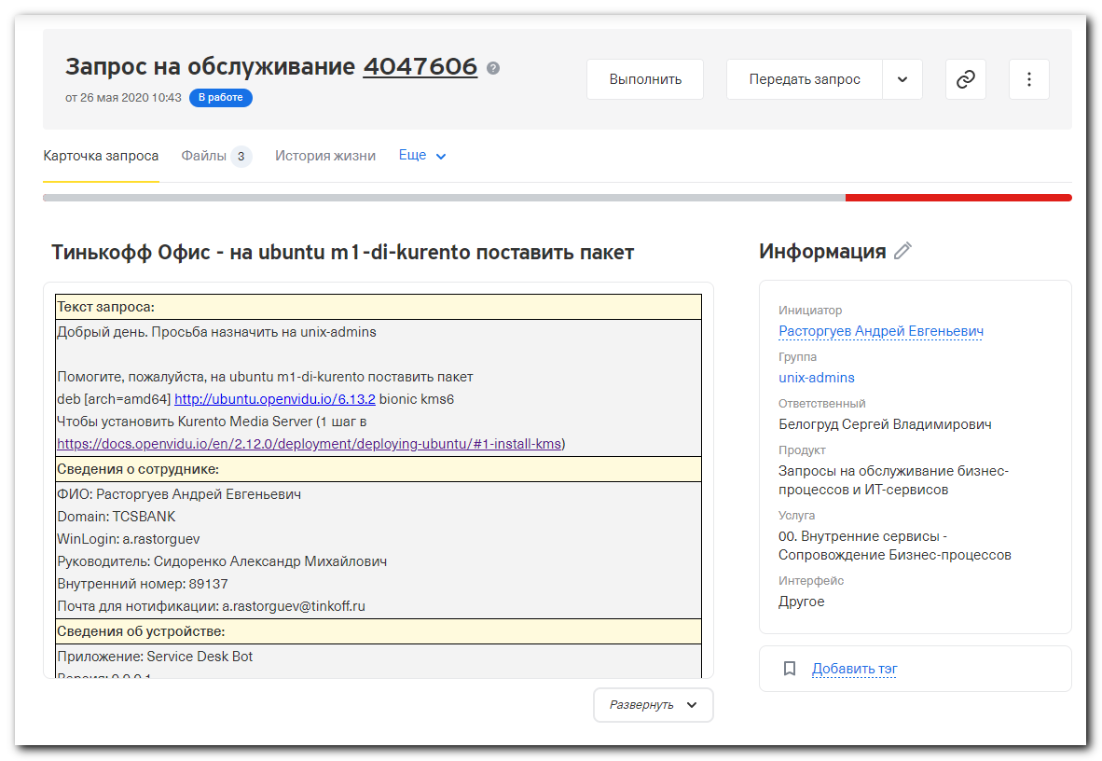
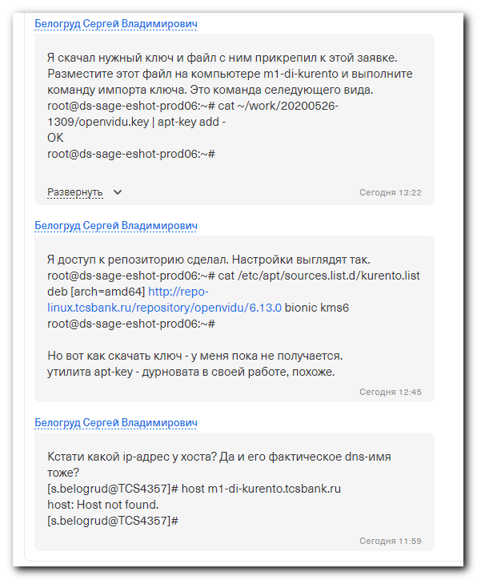

https://docs.openvidu.io/en/2.12.0/deployment/deploying-ubuntu/#1-install-kms
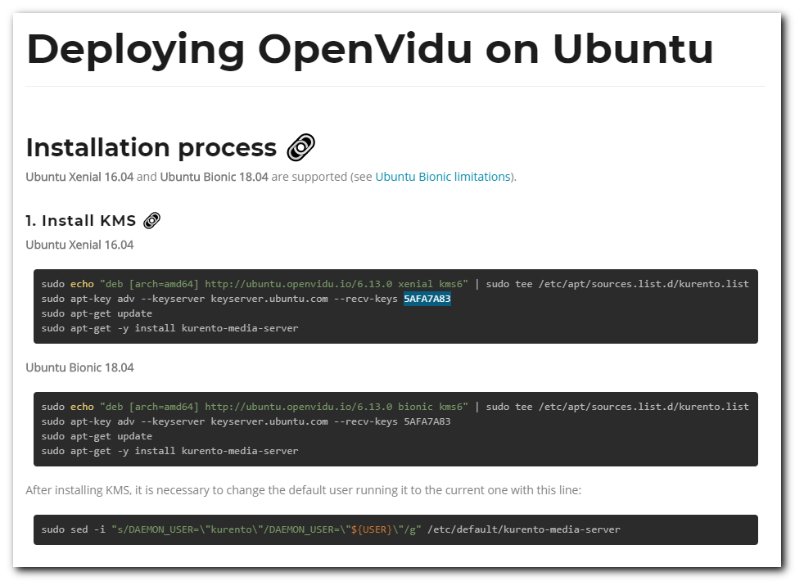

#
# I’ve created config in Nexus for this repository.
#
# http://m1-nexus01p.tcsbank.ru:8081/repository/openvidu/
# And result link that should be used.
# http://repo-linux.tcsbank.ru/repository/openvidu/

# Here are original recommendations from web-site.
sudo echo "deb [arch=amd64] http://ubuntu.openvidu.io/6.13.0 bionic kms6" | sudo tee /etc/apt/sources.list.d/kurento.list
sudo apt-key adv --keyserver keyserver.ubuntu.com --recv-keys 5AFA7A83
sudo apt-get update
sudo apt-get -y install kurento-media-server

# Here is for our case.
echo "deb [arch=amd64] http://repo-linux.tcsbank.ru/repository/openvidu/6.13.0 bionic kms6" | tee /etc/apt/sources.list.d/kurento.list

root@ds-sage-eshot-prod06:~# echo "deb [arch=amd64] http://repo-linux.tcsbank.ru/repository/openvidu/6.13.0 bionic kms6" | tee /etc/apt/sources.list.d/kurento.list
deb [arch=amd64] http://repo-linux.tcsbank.ru/repository/openvidu/6.13.0 bionic kms6
root@ds-sage-eshot-prod06:~# apt-get update
Hit:1 http://repo-linux.tcsbank.ru/ubuntu bionic InRelease
Hit:2 http://repo-linux.tcsbank.ru/ubuntu bionic-updates InRelease
Hit:3 http://repo-linux.tcsbank.ru/ubuntu bionic-backports InRelease
Hit:4 http://repo-linux.tcsbank.ru/ubuntu bionic-security InRelease
Get:5 http://repo-linux.tcsbank.ru/repository/openvidu/6.13.0 bionic InRelease [3,546 B]
Get:6 http://repo-linux.tcsbank.ru/puppetlabs/apt bionic InRelease [85.4 kB]
Err:5 http://repo-linux.tcsbank.ru/repository/openvidu/6.13.0 bionic InRelease
The following signatures couldn't be verified because the public key is not available: NO_PUBKEY 6CD4EC8C29BAB311
Reading package lists... Done
W: GPG error: http://repo-linux.tcsbank.ru/repository/openvidu/6.13.0 bionic InRelease: The following signatures couldn't be verified because the public key is not available: NO_PUBKEY 6CD4EC8C29BAB311
E: The repository 'http://repo-linux.tcsbank.ru/repository/openvidu/6.13.0 bionic InRelease' is not signed.
N: Updating from such a repository can't be done securely, and is therefore disabled by default.
N: See apt-secure(8) manpage for repository creation and user configuration details.
root@ds-sage-eshot-prod06:~#

# This way was found in one of my tests. But it was not worked. Perhaps it’s need to ask access from proxy.tinkoff.ru to keyserver.ubuntu.com.
# 20200331 Ubuntu 18.04 - how to get Dell repository - Openmanage
# sudo apt-key adv --keyserver-options http-proxy="http://<username>:<password>@<proxy_server_addr>:<proxy_port>" --keyserver hkp://keyserver.ubuntu.com:80 --recv-keys <key_to_import>

# I’ve tested access to proxy.tinkoff.ru:80 - it exists. I tested it on other available server with Ubuntu 18.04.
root@ds-sage-eshot-prod06:~# apt-key adv --keyserver-options http-proxy="http://proxy.tcsbank.ru:8080" --keyserver hkp://keyserver.ubuntu.com:80 --recv-keys 5AFA7A83
Executing: /tmp/apt-key-gpghome.umSpWCstXB/gpg.1.sh --keyserver-options http-proxy=http://proxy.tcsbank.ru:8080 --keyserver hkp://keyserver.ubuntu.com:80 --recv-keys 5AFA7A83
gpg: keyserver receive failed: No data
root@ds-sage-eshot-prod06:~# telnet proxy.tcsbank.ru 8080
Trying 10.218.6.50...
Connected to mwg3.gtm.tcsbank.ru.
Escape character is '^]'.
^]

telnet>
quit
Connection closed by foreign host.
root@ds-sage-eshot-prod06:~#

#
# Here I try to receive key from my workstation, where, under win 10 exists Ubuntu 16.04. I suppose for receiving gpg key it’s not significant.
#
#
# By the way, when I tried to find the key on web interface of http://keyserver.ubuntu.com via browser. I found nothing.
# So, the web interface of this site is useless. It could not be used to find keys and to test - is the key exists at all.
#
# For this format of command - it’s work.
root@TCS4357:~# sudo apt-key adv --keyserver hkp://keyserver.ubuntu.com:80 --recv-keys 5AFA7A83
Executing: /tmp/tmp.uYQ702cE5U/gpg.1.sh --keyserver
hkp://keyserver.ubuntu.com:80
--recv-keys
5AFA7A83
gpg: requesting key 5AFA7A83 from hkp server keyserver.ubuntu.com
gpg: key 5AFA7A83: public key "Openvidu - Kurento TEAM <openvidu@gmail.com>" imported
gpg: Total number processed: 1
gpg: imported: 1 (RSA: 1)
root@TCS4357:~#

# Here I’ve exported appropriate key, that I downloaded and installed in previous command.
root@TCS4357:~# apt-key export 5AFA7A83
-----BEGIN PGP PUBLIC KEY BLOCK-----
Version: GnuPG v1

mQINBFpiDEABEAC8AF5sPSiM6G7WMu9SEEr/LbVQk+K7zdTAH7dHjQ1mwSiFyi+M
OZd+73Eys6lg6yuw/fPjpNMO1SLxUEfo6FsKPkHRaLrB95W4LxaP9ufa//kyJCsS
SWhWE7B9y+iUQFtJWZ1VoBFGyYGODOy9Hz6fGdWHiGI5pm2pJ1v6rMAq3W0O8Bse
LQq6oT1MKIImD5DpOWgXS02NXCnep9rbLET4Qgk0JJId73golHLXbtz7/cFSc0DV
OoBoiUAfU4ADKGZqsxtU9ZDfQFxwG8j1VqOTZGcnGd1W8truQQDtFDZ0diQVF554
4EU7QojuLDuWzFHfuu2FC/9zB6DWHAvU4qPlvhxH1N13zITCgJ7ZvaHJjsZJ1DS+
J+feB000rtl7YlsFv0vgUICGv3AjTWtftdMrsAbsgX2um7DeXSM4cx3fLjvJIv+t
n9IyFJ+hJPymKI9j05Mg+dhQXMHbaN3hcx45NNtTjQ9Fk4sl9phTGOgT7s69aVh3
w1bH5wUYsFB4bYaV2RAc3ruUGBoOj11sbbtSasSPJqoawdm9n4ILIdAkG1talBwY
dKNl819FvxZx6M0D0T3JtN2K6hJqKenSjw3pOs5eXDhakV5fz9r11crjRpwLvztB
E/tXrrcmT92urb/4WtpjHYjiVZEL2rhyObphU9Qo5MHCOruV3hV1fXPjbQARAQAB
tCxPcGVudmlkdSAtIEt1cmVudG8gVEVBTSA8b3BlbnZpZHVAZ21haWwuY29tPokC
PgQTAQIAKAUCWmIMQAIbAwUJEswDAAYLCQgHAwIGFQgCCQoLBBYCAwECHgECF4AA
CgkQ/IoWYlr6eoOmoA//XVkfOk/qmk/FKJNLRCbKCEOtPI0hgv/wSZubJS0KnBPa
SJT8xjGUlDOYgho6KtQrJqzDbwf+MBfp2waQbYuKF6oTtwoLfqNBbQJHbUnH+RW0
bSGGcPGa9MeP8lvv7rkbRoM/mk29YE5SVfUiIjjaotyBNyK0pYMixrtUVAh/2mZm
4S9UmErtwaOb+rzlhdmdc+piKM2bo5tsZ+oExmbnyhcy6pZ1JfjYvY+L1d7wRtDe
0rt/rapWNxA1lQDwHPkAq4AGc+Nqoct060JP40TZm9EM3XTpl2JxALtdDs7dii/d
h8TidKWem4Vm5d+hH31ARrdmk+/sMYBKwit39FGKX2vvK7mQVYOkoTqGsTi7hCRL
4CLEj3a/fv+i1AC1MeyIBZvXyVIo3v2J5EcYIYZS3aPjgZTCAppRteY1ahC1JtnV
PAdKZLZPOSizVHxecFbO4wZXtr+UhOYGsXCVikJTj5mcdmlDVoe7wLfklhiABa2D
iyzesGsqjfInOotk7/lrqy1Zmqnya4XUwhZoGfeYVJeXpIkeE619z+6P250nQ3Ju
Aneb6XR4Ea0OM0XKxCcApDByV4phElaIC7bIvRh3uXw+8gvvzKOVASGtjGC+f2NA
o/FXHYIKcAT3o7FnfL6HN4LVbqvWT7b5OnMJj7HKJWBcMVU46pngZSw6Yx1P6eK5
Ag0EWmIMrAEQALD0myxvJW1YhdPi9apPkyi9T+khN4cJ+Vhh25aJ2fE/GScz+u3C
U4NZiQdRW+jgVL8ECGREaWI0JRhIxtbq5XGJH11t6TBHNy22t7eoTihNkHm0zQID
mro/O7ySdozb5xChq0zWxMyLQufeLIoZVbOaNCM65rb/u/KxbWj3jizcEJay52dP
qN+rNzUTsfgiMyuv7DNo7ssj6epjFlPYxQ+CnIQC7paxHa7Mji5nJGI6WBiigaZh
/7cpOz6xhx6f9iGb3cC7cnP9EEB3PQeqYXZJV7mCwGVpRV+lP2AGsn/7+Rr5DCdo
yBNWT16Otaltds7CMkr9oDd6Qm+CBsRd/S7pfKmTBkH5/Us39a/Z8IpOGYkI0Ny6
SLQ/DR8LReeHnhdsJNfeIOxrWtajo2wHEnuXqGKvHPc3B0Wh9GNm23RXQ1nF4B+b
1JvDFtLrXi8/Bl8uHgPeXW+zF+k1dnezDXaT9DQuANkKpPHp2CdBZKsiGMXx6jpA
qvCEeyYnOVxGKfja9vVzCFLFT8xzRXuRYNMrcneKlkg1pkNTL1GTufxW0HhveJzL
goaEMNo0rYakhyfmp8H2UpkZxoDL6eHHr9+6jUjVUV0KkY0KeF032n9I0ctv+rHp
Kr2n3gEw6qzuB3dHd+dKrA9VZphnopuyAuiz2I5MSx2Bp/4L8xC3mphNABEBAAGJ
BEQEGAECAA8FAlpiDKwCGwIFCRLMAwACKQkQ/IoWYlr6eoPBXSAEGQECAAYFAlpi
DKwACgkQbNTsjCm6sxG+zQ/+P2Hw7Yi8YpNtrFrToO9STzpQKaveaFvwKRXRiJOm
A6/bFwruRRJIop6IPZJ08xTSZsGxDuMtZkjESFbBmkXz/XLBhtnfInIsDmD6Je7/
x4MT5UR+MisWzkwU1YWRULvW27EGCb9hV+tSa+feNL3lAC7lMIsVaD0GUM5dP7Dm
oSVuieXn5/FwLv9mo7Ra/DWQ9UYd/UUwSOavz8oWb5S/Dpos5yLe1n7xz2FFeb0V
DOU7bNUhD8RHWq5r2CPf8wYYAT6y6M/rbCBuiKWjrJsgB6Kfe5ExC255VzJK1wsz
W2kUjfaXfbhDb6zYaJ0BgLXD0X7Wu2ifsmWwF4emMCbnQT1HBg29zAOAOuB5USuI
QMVAVllt+5JLBIRVYbT0gvvkvWsuWUxIuVbwc/bCYaFd8GFu3b0QY5I5r5BLehjT
LjG3/39r7AqVepXgAUsab0LxZtPRuvlk/RSmRzrnXRcfUdIdAPL46/CLSr7csAjY
okuh+4k/lnFZovaVpexO3AlHSNcOczRCus0Ee1oi9FmB42F4ptT4trlMm/AmLgH8
QO1fAvGTKVgTOzdPOymxbF77z68zGcc93oNorES59TszAPva7AS23syzB+PwWFx/
qdW2zpdjqDFGG9jDqh5wVHbpk/j3f17JNITTgZbUubDatZ+FbrhfDh6OqyEYyB3F
V22PjQ/+LqtdtlkB/7s0uhoE/UTo3PQxC7S3bouAU89JsjnMNgcRvxNT3qdy+T45
coYaF1vmBswwA3EIQnSLtHVaqjNz5BWhJWM05YjwTwgXwZAinozJ3hWwg/OjZAFg
RXdSPd2UiSe7IxK/s6HOw1RCZQDUf5jZc0zOf+bTCt2Ln9mKCXPXmLQX4T4XdO1t
KYzDF5bXDaQm83vlFQ/jbRsVCq0apUn4QQd6WPGXQ0BNibeJlr01a7rJ8290vcQF
uLnzUKjzeUA4anp7ycus5L1+lCZdtIehXP6Wds4IkxZDwioYywST4WzAgQQsMm8C
GkPB+MniTgggDvjUfQ25Uk/mp6mglbbAcx3byFj9gkakim3IQ5medTzbRtcWKSKx
d6TdzRVJlZ01t338jnsgA58vj7YsBJcESkiHD/meiPaZFoDMliKT41u9rzospiiI
PoRxMWc8YJ0fbswVv8sPkp+Morvu8lEdPv+R6yWlxIVKts3eYYkQG8xqqNWUWde/
mY042YUwWIalxoLWSK5XHaclpSey111fPIvFTCXZTR7sSrXk6+4XFEJ7MHr0bA2q
SxJylsVYREQA3+GJQbTsgKDO6BPAkPiSEZUOCge7uJ9zjQSdwjCPEult3QQv9Xt1
/y+oa/Hu6RBxXkhwyruZsNB7QVs1fbjdSkA6myYgGuV8ZORViva5Ag0EWmIMQAEQ
AN9MAUyx/4gXXXyWxjTas3ptrvfthBYX7ZGw0QBAwiwZ5T3RidnAPHUrhhMRyiWM
DW+JXBKPIgZKUlj9ilVJN3pKJjDlqnWtfx9EzPD5tBPNjJLsZChZOf14THgdSDH/
nXWSTexIFfUIqJPiAdwyo6Xr3l5zbWVWddvXU8Slen2X3/+pHPAmhS3Dl9b4v21p
Tunq43JsjybhWURlqEUi/a9DCMECM1fzc2h4H8lLY1dBtGO8cqYWuEi1o+bkTNI0
gb1kgP+jmBXLGV0TTi1shLMrdKFkQuFP1E9CLTztCcqOQVyiPgzQU7snQkKWTiZv
TOJT6Xprn0XbBO0FjX7XZI96jzNN2qd2OMHOApV67+37ImapH8tvV+UMQ/LSmdaN
I+k2SECYda1vKkyYG8KamCjsjLBE+0eqeka0bVJOnsgxRoaSkyRycMO9e3ToHyMM
kTDaU2kmH6X685NBfOooW5ez60xgGnkDJMDJeChdS/L1H+jZ1Q9zqYhGRwbOSh3J
sM2R+ErwIZDyWGC1gQ3gbk1F/5PhXeFnwqk6dBwDCDYhsJfbsJyHb7BvQmOIDnb0
TA8SgOt1wGdbTRy1bYChJvlzhNtY1Lwcf0EUjTAo9utL1+RH3AVmkdGFZ60z2m7+
UjOFrqAnR2mwPS9156+cwYV1G08OmQyplWxjukaya/HTABEBAAGJAiUEGAECAA8F
AlpiDEACGwwFCRLMAwAACgkQ/IoWYlr6eoO73RAAiTMmj9bzyf+uYYFLlB0BlRk0
5ybeyDTSfyCYXTR8CPEkxDVM0pkfdakj5pDFeqf0rbnC3krt1IGlgvkV40dLi9xd
L21VRKaHZkExTM1z7Mc3vuhGHcIHHp8gamEAiYcLV/4XTkz/cIzgWd1c4+K1pO4G
y5i7knQlAL7JwLQAw/d7w5DeSjsLSpdP5cW5LidkFR2H7rKL7XnchEfslWJmThVP
vtuWnAARX0Dp+gHwLHM5yT0Dv9KpiOPgqhB8KtWoLw4POTZHvWcWp59LzL6suEoL
HqZP08ItDHyhpwPAIEFf4uNBlzpdIHEoOxZQos9tQ1kSKK6isPezNLNnE9oU3z8J
9OQqDehpWf2C9cogZEzv2gqc/VWBNdTVuBw99BgIfAG18C5E5/DL1Tk3FlkIfjNv
IMPIqWSJFsSW2gerQXxQP4HOeUfVNjDji5mJy1By5BD6AjzG2gfY33skkYWAAUzh
Lf5lxgbvcQ5Q0Qy2NuUT60zIX6sJIWbljBE6aZZLtSinEJXQVjFttNNmk6QDcSeQ
kUSfUS9GFKdF1T+pd0mXbH59Ef3g/eOzuw/Kb+P/65ZgpKBwiZyL+onsnkMZ8+v2
HCbuvY1nPSDhvbi0vtW2gneFbUAaBl4nQW1Sim0P9juHFKDcHeiL0zwhXVqs0hDR
ZxCE3N7xNSDywk9HtQU=
=2MCa
-----END PGP PUBLIC KEY BLOCK-----
root@TCS4357:~#

#
# On target testing server I copy and paste this key to file.
root@ds-sage-eshot-prod06:~# mkdir -p ~/work/20200526-1309
#
# I've copied the key from above from Notepad++
#
root@ds-sage-eshot-prod06:~# cat > ~/work/20200526-1309/openvidu.key

# And the gpg key was successfully added!
root@ds-sage-eshot-prod06:~# cat ~/work/20200526-1309/openvidu.key | apt-key add -
OK
root@ds-sage-eshot-prod06:~#

# After was added the gpg key - repository became available.
root@ds-sage-eshot-prod06:~# apt-get update
Hit:1 http://repo-linux.tcsbank.ru/ubuntu bionic InRelease
Hit:2 http://repo-linux.tcsbank.ru/ubuntu bionic-updates InRelease
Hit:3 http://repo-linux.tcsbank.ru/ubuntu bionic-backports InRelease
Hit:4 http://repo-linux.tcsbank.ru/ubuntu bionic-security InRelease
Get:5 http://repo-linux.tcsbank.ru/repository/openvidu/6.13.0 bionic InRelease [3,546 B]
Get:6 http://repo-linux.tcsbank.ru/puppetlabs/apt bionic InRelease [85.4 kB]
Get:7 http://repo-linux.tcsbank.ru/repository/openvidu/6.13.0 bionic/kms6 amd64 Packages [34.5 kB]
Fetched 120 kB in 1s (91.0 kB/s)
Reading package lists... Done
root@ds-sage-eshot-prod06:~#

# If it needs - we can list already imported gpg keys.
root@TCS4357:~# apt-key list
...

pub 4096R/5AFA7A83 2018-01-19 [expires: 2028-01-17]
uid Openvidu - Kurento TEAM <openvidu@gmail.com>
sub 4096R/29BAB311 2018-01-19 [expires: 2028-01-17]
sub 4096R/02AB0385 2018-01-19 [expires: 2028-01-17]

/etc/apt/trusted.gpg.d/ansible_ubuntu_ansible.gpg
-------------------------------------------------
pub 4096R/7BB9C367 2014-06-10
uid Launchpad PPA for Ansible, Inc.

/etc/apt/trusted.gpg.d/openjdk-r_ubuntu_ppa.gpg
-----------------------------------------------
pub 1024R/86F44E2A 2010-04-12
uid Launchpad OpenJDK builds (all archs)

/etc/apt/trusted.gpg.d/webupd8team_ubuntu_java.gpg
--------------------------------------------------
pub 1024R/EEA14886 2010-05-04
uid Launchpad VLC

root@TCS4357:~#

#
# To send the key via attachments of Service Desk task, I’ve exported it directly to the file. After that I’ve attaced this file to SD task with appropriate comment.
root@TCS4357:~# apt-key export 5AFA7A83 > /mnt/c/share/openvidu.key
root@TCS4357:~# vim /mnt/c/share/openvidu.key -R

[s.belogrud@TCS4357]# scp /drives/c/share/openvidu.key bsv@ds-sage-eshot-prod06:/tmp/
openvidu.key 100% 5318 727.1KB/s 00:00
[s.belogrud@TCS4357]#

-----------------------
# Here are additional thoughts.
#
# This is an example, if we have docker on our workstation we can get some image of ubuntu (for example) and test somethin in it.
# https://github.com/OpenVidu/openvidu/issues/371
#

docker run --rm -i ubuntu:18.04 /bin/bash <<'EOL'
apt-get update && apt-get install --yes gnupg
apt-key adv --keyserver keyserver.ubuntu.com --recv-keys 5AFA7A83
EOL

#
# 20200907
#
root@ds-splunk-nidx01:~# apt-key add /tmp/apt.key.dell.key
OK
root@ds-splunk-nidx01:~#

